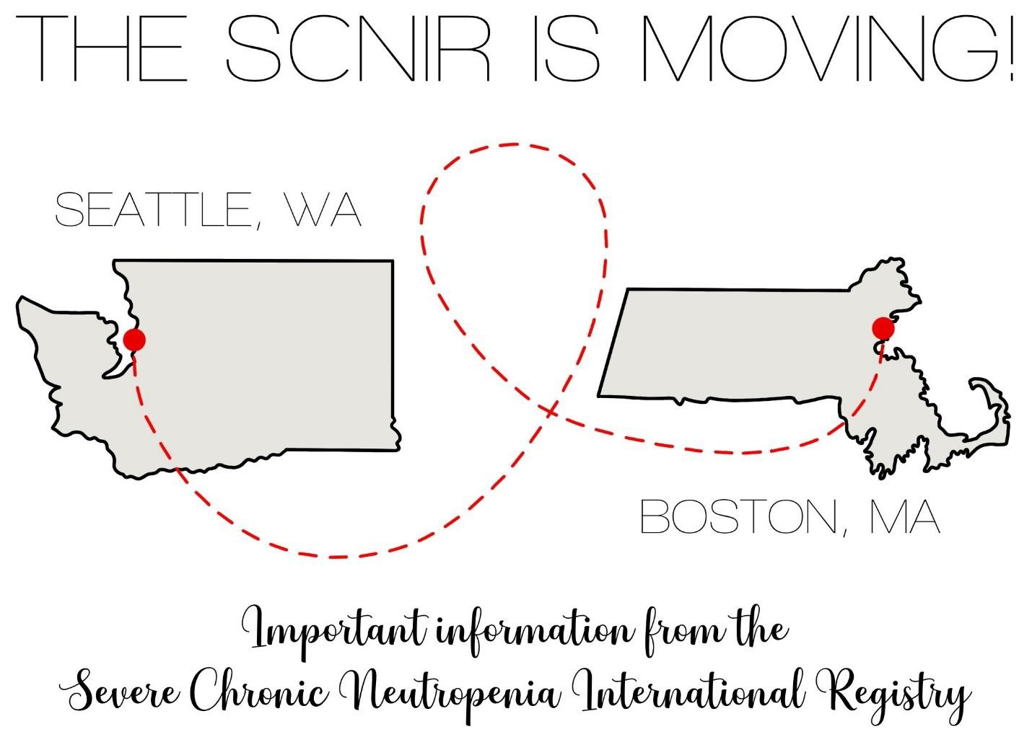

**Important Information from the**

**Severe Chronic Neutropenia International Registry**

The Severe Chronic Neutropenia International Registry (SCNIR) will now be located at Boston Children’s Hospital! The Registry’s new Directors are Dr. Akiko Shimamura and Dr. Peter Newburger; they will still be working closely with Dr. David Dale and Audrey Anna Bolyard in Seattle.

**What Does This Mean for Me?**

All clinical data previously collected when the SCNIR was in Seattle are being shared with SCNIR Boston. New clinical data and biological samples will now be sent to Boston Children’s Hospital.

We need to re-consent you to the Boston Children’s Hospital SCNIR protocol so that you can continue to share updates and samples. This consent discussion can be done remotely with an electronic form If you are interested in re-consenting, please reach out to our team at [SCNIR-dl@childrens.harvard.edu](mailto:SCNIR-dl@childrens.harvard.edu) or 617-919-1574.

The SCNIR transfer to Boston will not impact your ability to receive your G-CSF (e.g. Neupogen) medication from the KnippeRx pharmacy (if provided by Amgen) or from your local provider and pharmacy.

**Who Is the Best Contact?**

Karyn Brundige, who will be working closely with Audrey Anna Bolyard, is a pediatric nurse practitioner in the bone marrow failure and hematology programs at Boston Children's Hospital. Karyn is available to patients and families for clinical questions about neutropenia and the SCNIR. To contact Karyn, please email [SCNIR-dl@childrens.harvard.edu](mailto:SCNIR-dl@childrens.harvard.edu)

**Where Can I Receive Communication?**

We are currently constructing a new SCNIR website to keep you informed of the updates and advances from the SCNIR. The website will also include a link for you to send messages or questions to the SCNIR. You can visit our website here: <https://www.scnir.org/>

If you have questions or wish to contact us for any reason, please email [SCNIR-dl@childrens.harvard.edu](mailto:SCNIR-dl@childrens.harvard.edu) or call 617-919-1574.

We look forward to continuing to work together to improve diagnosis, treatment, and health of people with severe chronic neutropenia!